  

**MADRAS INSTITUTE OF TECHNOLOGY**

**ANNA UNIVERSITY**

**DEPARTMENT OF INFORMATION TECHNOLOGY**

**DATABASE MANAGEMENT SYSTEMS LABORATORY**

**IT5312 REGULATION-2019**

**PROJECT TITLE :** TIME TABLE MANAGEMENT SYSTEM

**PROJECT TEAM** **:** DEVADHARSHINIB (2021506015)

JAIKIRAN R (2021506029)

JEEVANANTHAM V (2021506031)

**DEPARTMENT** **:** DEPARTMENT OF INFORMATION TECHNOLOGY

**SUBJECT**  **CODE** **:** IT5311

**SUBJECT TITLE** **:** DATABASE MANAGEMENT

SYSTEMS LABORATORY

|  |
| --- |
| **TIMETABLE MANAGEMENT SYSTEM** |

**PROBLEM STATEMENT:**

To develop a database regarding creation and maintenance of academic timetable for the individual semesters and also for the individual

faculties automatically.

**OBJECTIVES:**

The main objective of this project is to design a **Relational DBMS software** that

Encloses the following object:

1. To reduce the manual work to generate the timetable for the institutions.

2. To increase the efficiency of managing the Timetable for the individual semesters and also for the individual faculties with clash.

3. To manage the details of the Timetable, Faculty, Room, Semester,

Subject.

4. To monitor the information and transaction of the Semester, Lecture rooms and faculties availability.

5. To improve the searching facilities based on various factors such as

timetable, room, semester, faculty.

6. To edit, add and update and delete the records to improve the results of the database.

**INPUT / OUTPUT DATA:**

The Timetable Management Database requires the following input data:

* Teachers Information
* Subject Information
* Classrooms Information

The Timetable Management Database generates the following output data:

* Timetable for the individual semester
* Timetable for the individual faculty

**PROCESS FLOW DIAGRAM:**

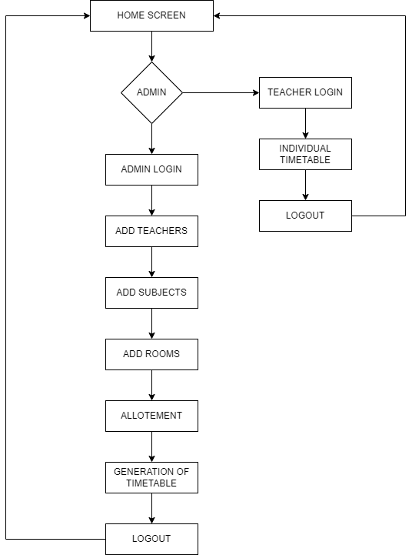

**DATABASE SCHEMA:**

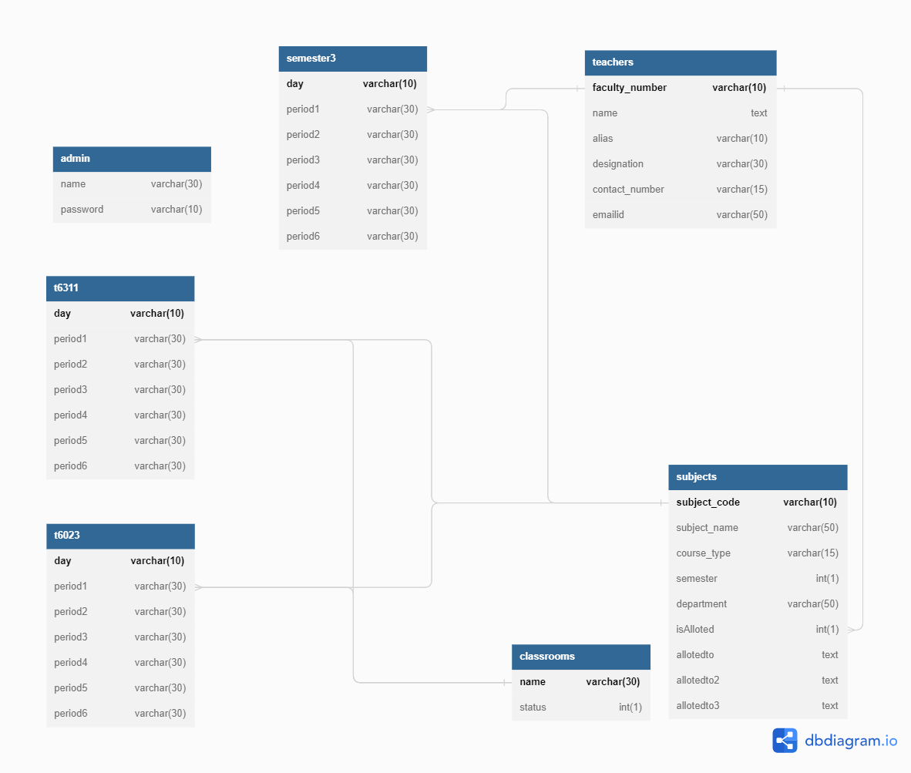

**PROGRAMMING LANGUAGES USED:**

1. My-SQL
2. PHP- SERVER SCRIPTING
3. WEB PAGE DESIGNING:
4. HTML
5. CSS
6. JAVA SCRIPT

**ER DIAGRAM:**

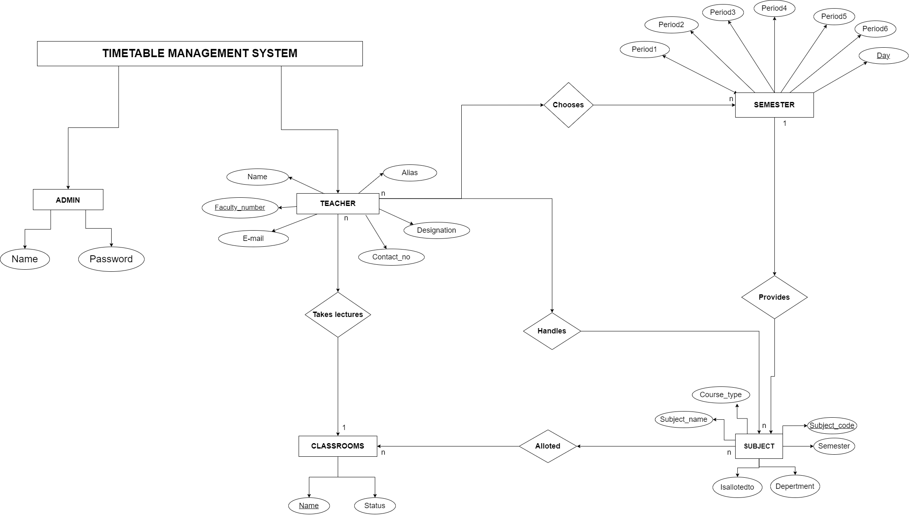

**PROJECT OUTCOME:**

**USER INTERFACE DESIGN:**

The UI for the database is designed using web development tools such as HTML5, CSS, Bootstrap. Java script is used for form validation and PHP- MySQL Connectivity is used to connect the database at the backend to the frontend.

**FUNCTIONALITIES OUTPUT SCREENSHOTS WITH THE DESCRIPTIONS:**

HOMEPAGE:

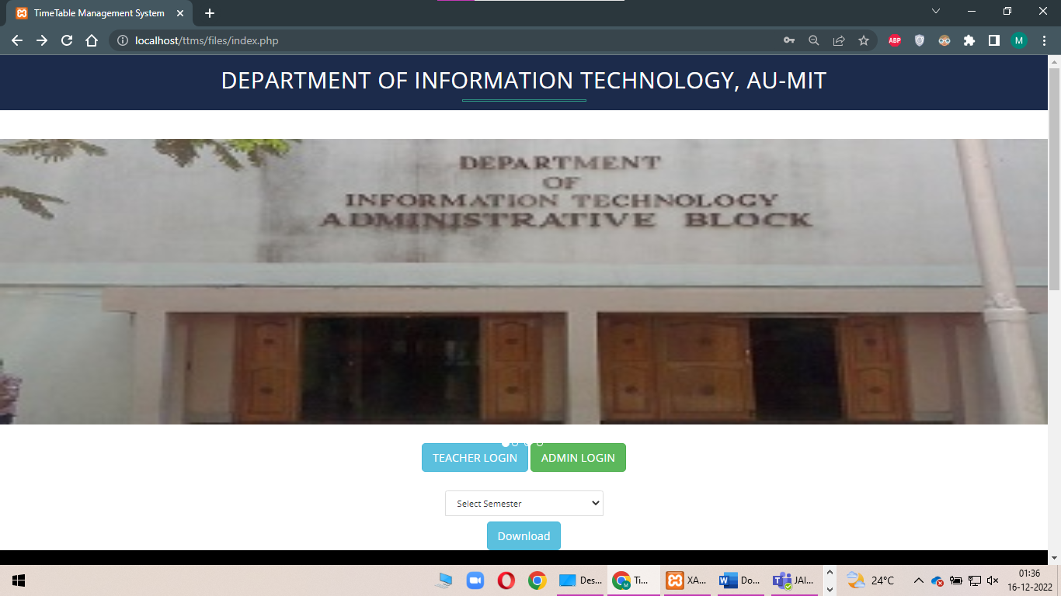

Fig 1.A Homepage

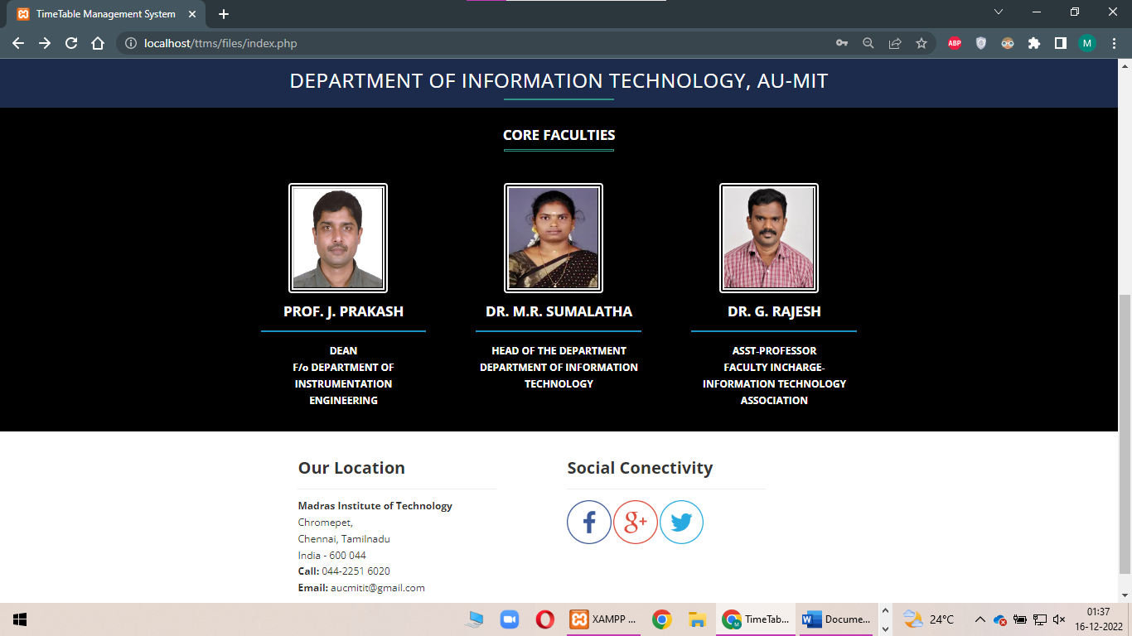

Fig 1.B Homepage

The homepage consists for the basic information of the department such as

Some snaps of the department, The details of the core faculties of the department,

Location of the department and the social connectivity details.

Also the home page asks for the admin and the teacher login. By clicking the admin button it asks for the username and the password and redirects to the page after the successful login. The same process follows for the teacher login.

Also it asks for choosing the semester and we can download the selected semester timetable by clicking the download button only after selecting the semester.

**CLICKING ADMIN LOGIN:**

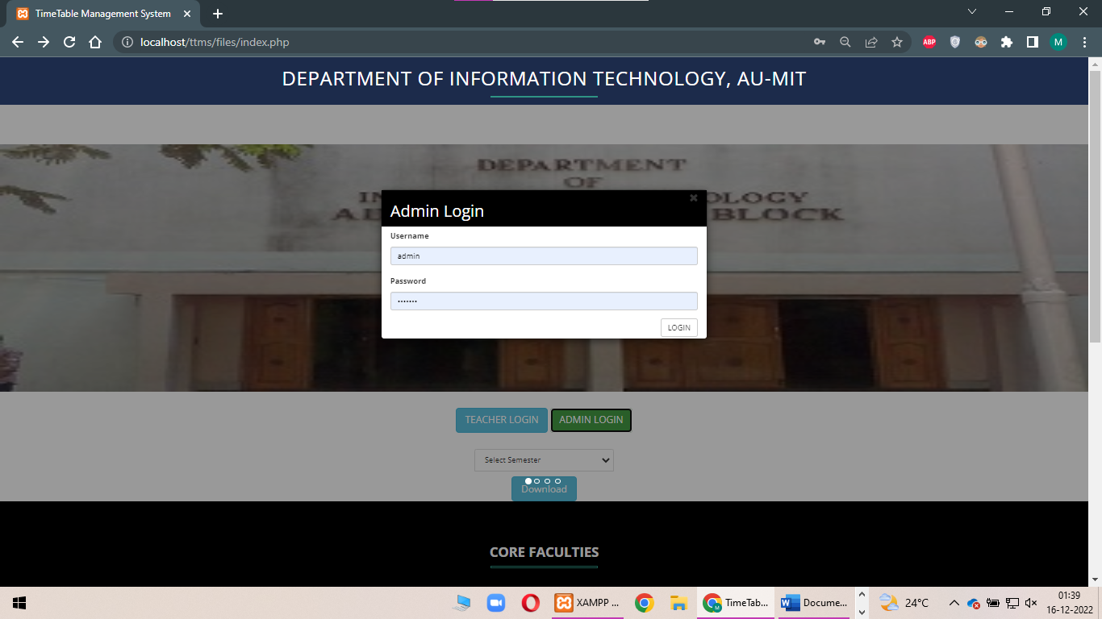

Fig 1C Homepage – Admin login Page

This admin login asks for the Username and the password. After the successful login it redirects to the admin page, where we can access and manage all the records.

**AFTER LOGING IN:**

The admin page contains the navigation bar which consists of the add teacher, add subject, add classrooms, allotment, generate timetable and the logout. The following screenshots provides the details of all the individual buttons:

**TEACHERS DETAILS:**

This provides the details of the teachers. Also it provides the add teacher option by clicking that we can add the new teacher to the database. Also by clicking the Import Excel button the teachers details will be downloaded as the excel sheet.

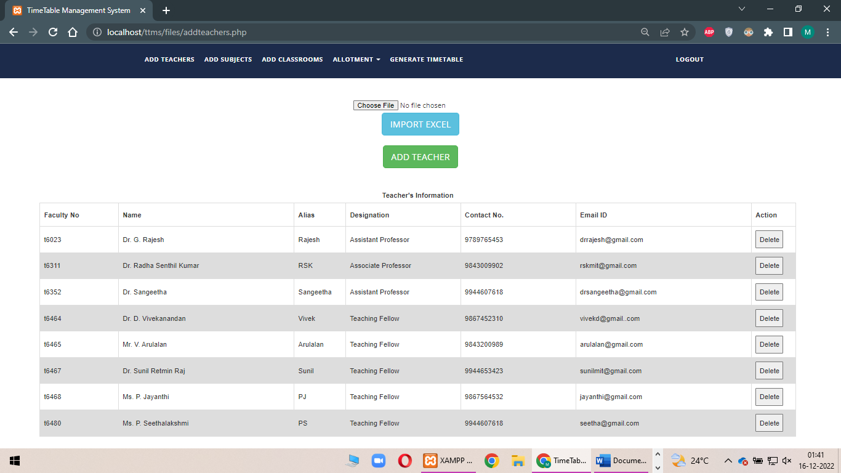

Fig 2A Admin page – Add teacher option

**ADDING THE TEACHER:**

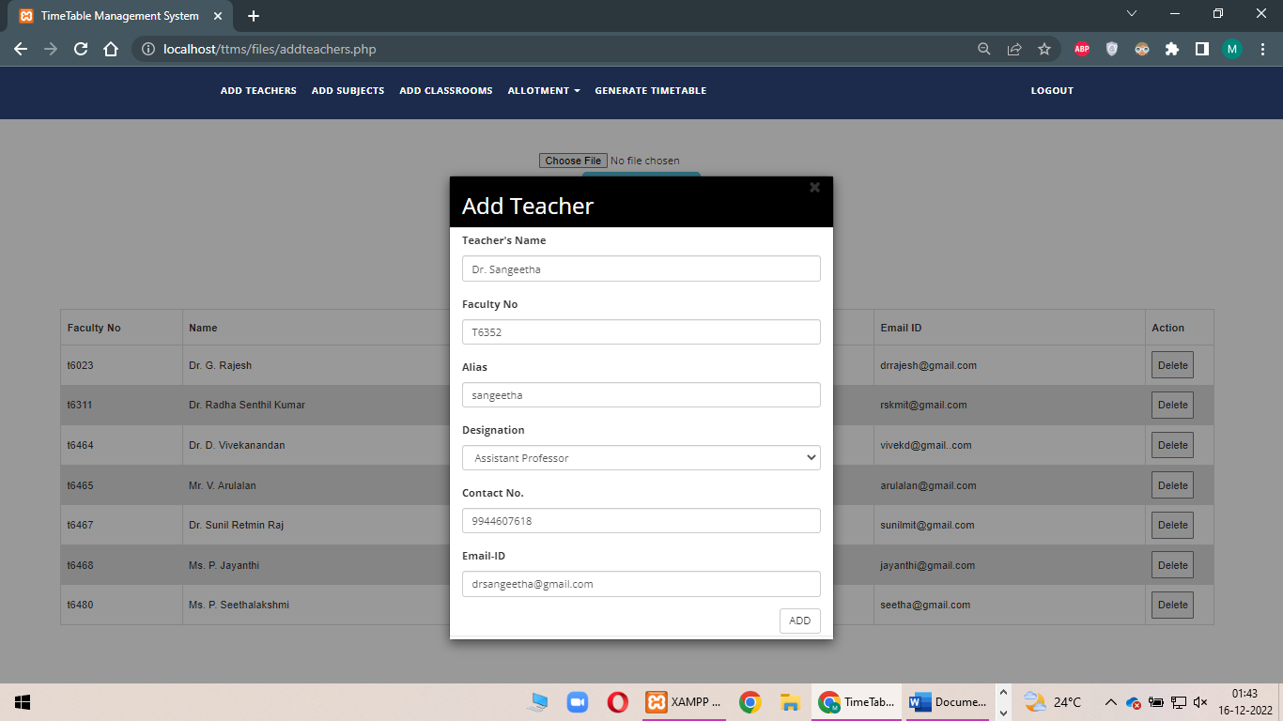

**AFTER CLICKING THE ADD:**

After entering all the details, by clicking the add button the teacher get added to the database.



Fig 2C Admin page – Add Teachers

Successfully the teacher got added.

**SUBJECT DETAILS:**

This provides the details of the subjects . Also it provides the add subject option by clicking that we can add the new subject to the database. Also by clicking the Import Excel button the subject details will be downloaded as the excel sheet.

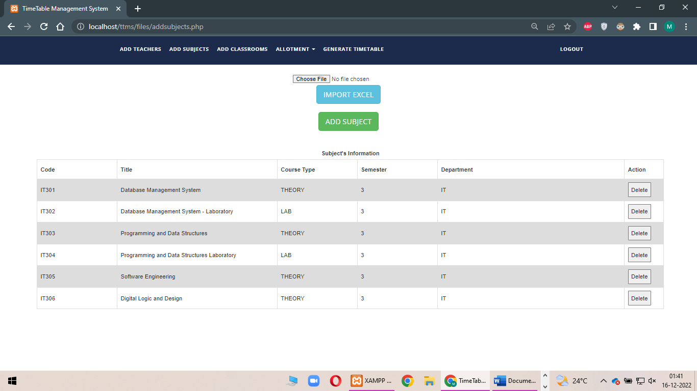

Fig 2D Admin Page – Add Subjects

**ADDING THE SUBJECT:**

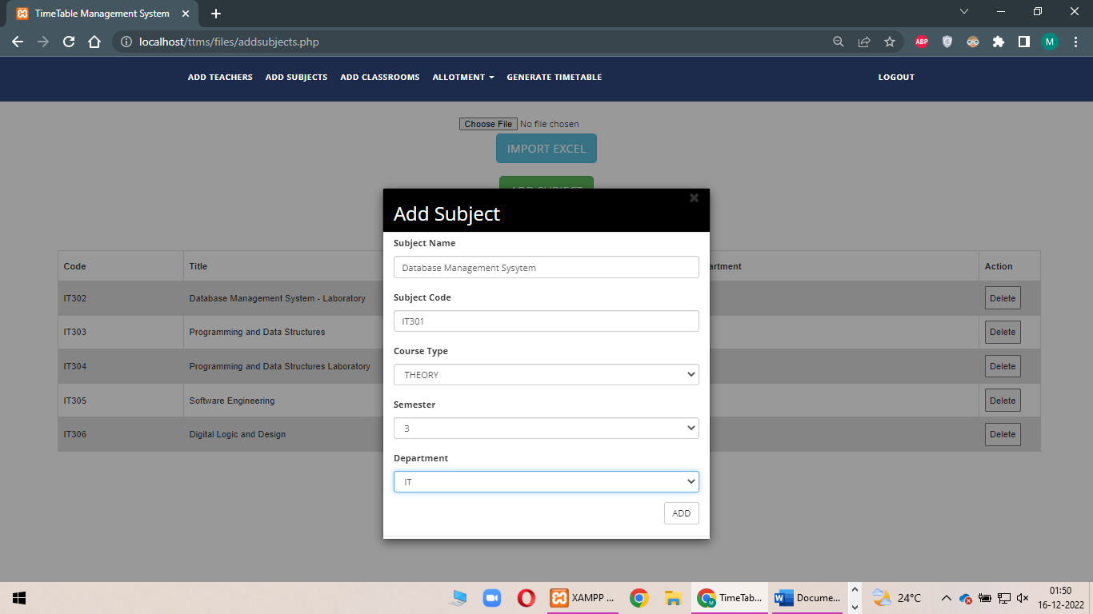

Fig 2E Admin Page – Add Subjects

This pages asks for the subjects details. Subject details such as subject name,

Subject code, course type, semester, department.

**AFTER CLICKING THE ADD:**

After entering all the details, by clicking the add button the subject get added to the database.



Fig 2F Admin Page – Add Subjects

Successfully the subject got added.

**CLASSROOM DETAILS:**

This provides the details of the classrooms. Also it provides the add classroom option by clicking that we can add the new classroom to the database.

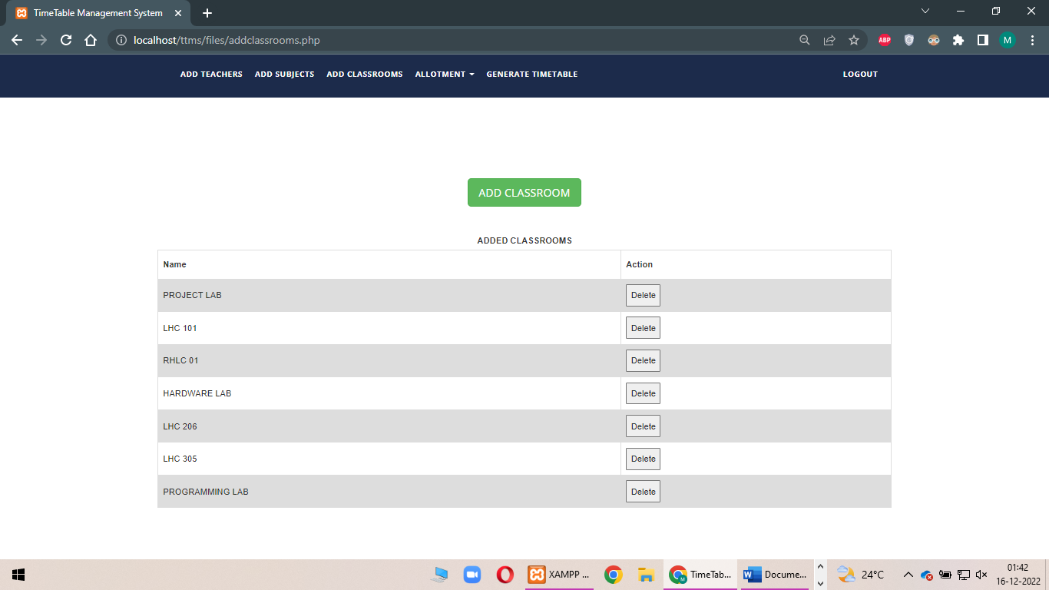

Fig 2G Admin Page – Add classrooms

**ADDING THE CLASSROOM:**

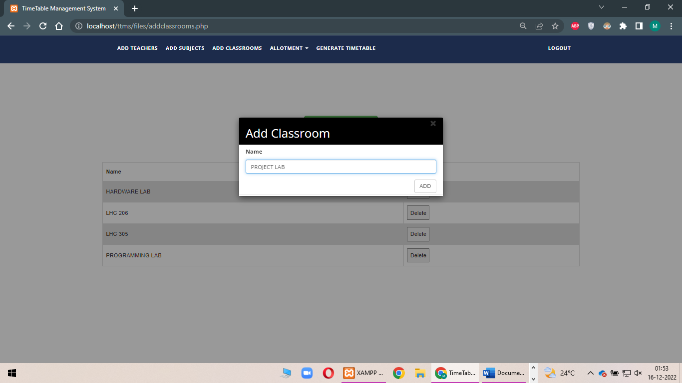

Fig 2H Admin Page – Add Classrooms

This pages asks for the subjects details such as the Classroom Name.

**AFTER ADDING THE CLASS ROOM:**

After entering all the details, by clicking the add button the subject get added to the database.

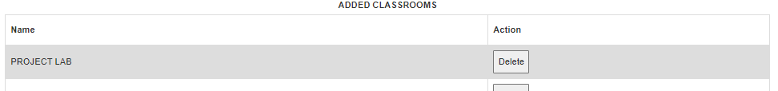

Fig 2I Admin Page – Add Classrooms

Successfully the new classroom got entered.

**ALLOTING THE TEACHERS FOR THE SUBJECTS:**

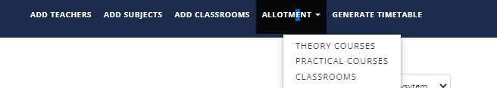

Fig 2J Admin Page: Allotment of the Subjects

THEORY COURSES – TO ADD TEACHERS TAKING THEORY CLASSES.

PRATICAL COURSES – TO ADD TEACHERS TAKING LAB CLASSES.

CLASSROOMS – TO ALLOT CLASSROOM FOR THE CLASSES.

**ALOTTING THE THEORY SUBJECT TO THE APPROPRIATE STAFF:**

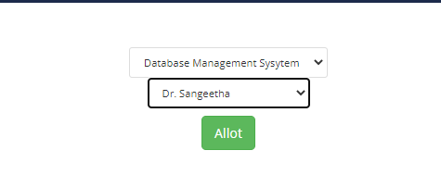

Fig 2K Admin Page: Allotment - Theory Subjects

**AFTER CLICKING ALLOT:**

This page allows the allotment of the subject to the teachers. By selecting the teacher and adding the subject the selected teacher will be allotted to the opted subject. This is for the theory subjects.

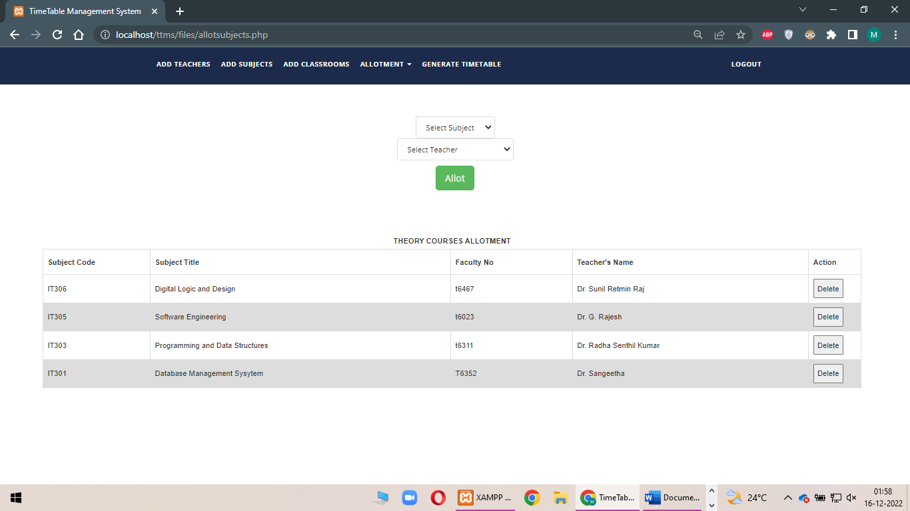Fig 2L Admin Page: Allotment- Theory Subjects

Successfully the selected subject is allotted for the selected staff.

**ALLOTING THE PRACTICAL COURSES:**

This page allows the allotment of the subject to the teachers. By selecting the teacher and adding the subject the selected teacher will be allotted to the opted subject. This is for the practical subjects.

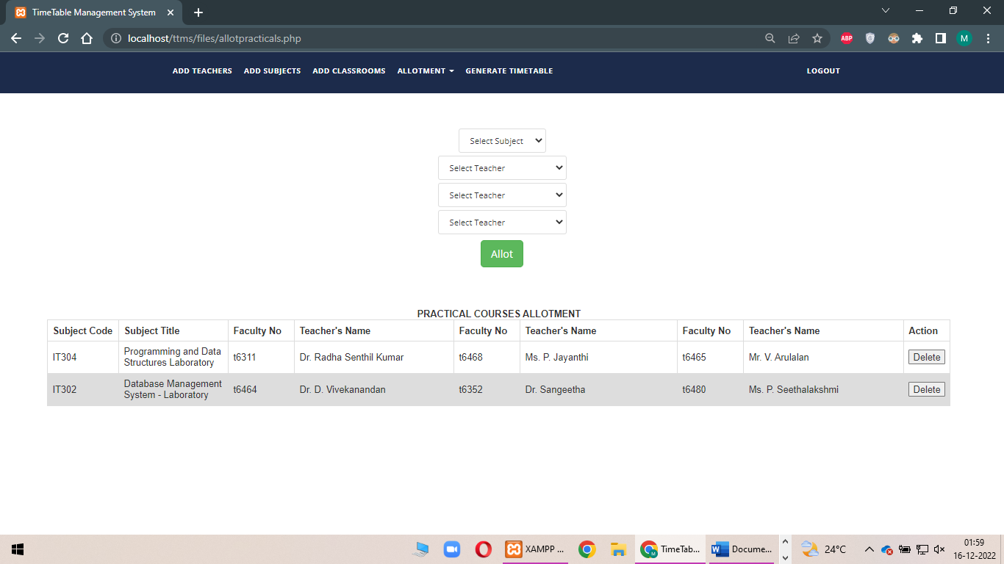

Fig 2M Admin Page: Allotment – Practical Subjects

**ALLOTING THE CLASSROOMS:**

This page allows to select the classroom for the respective courses entered.

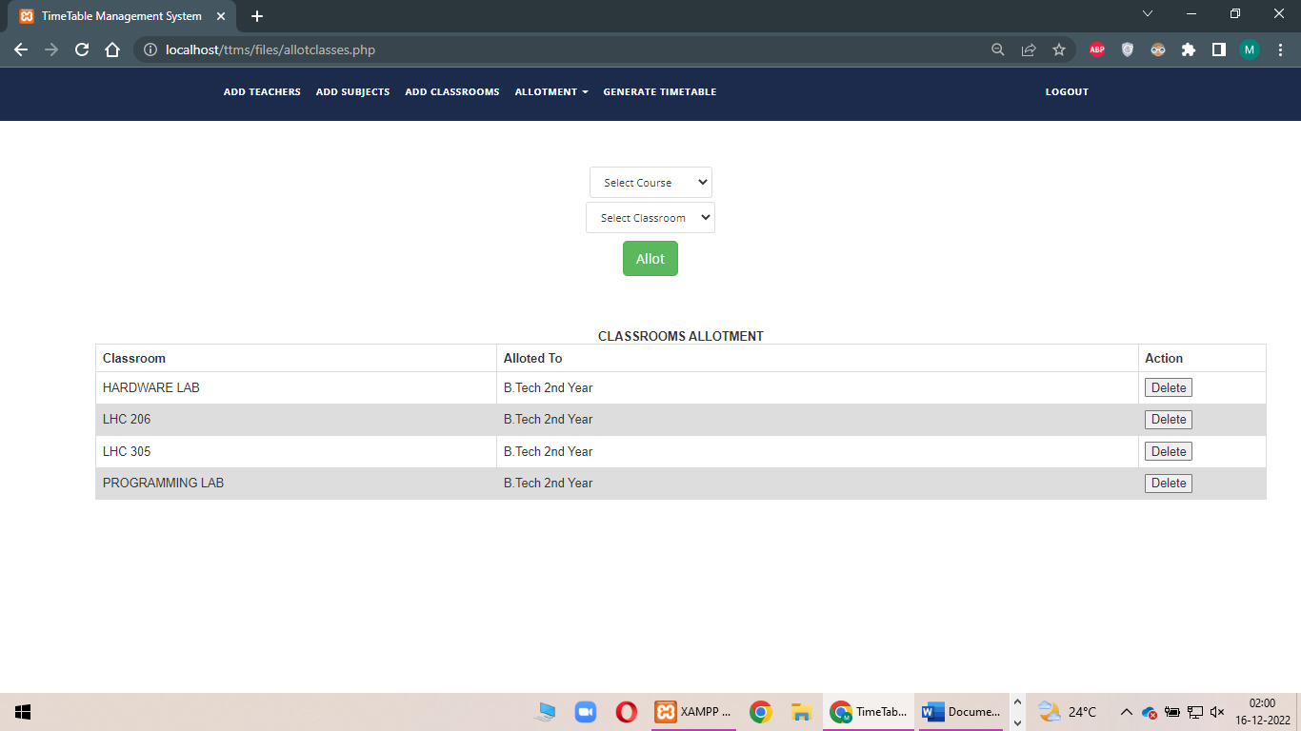

Fig 2N Admin Page: Allotment – Classrooms

**AFTER THE ALLOTMENT OF ALL THE SUBJECTS TO THE APPROPRIATE TEACHERS WITH CLASSROOMS:**

**GENRATION OF THE TIMETABLE PAGE:**

This page generates the timetable. By selecting the semester and clicking the generate button we can get the timetable for the entered semester.

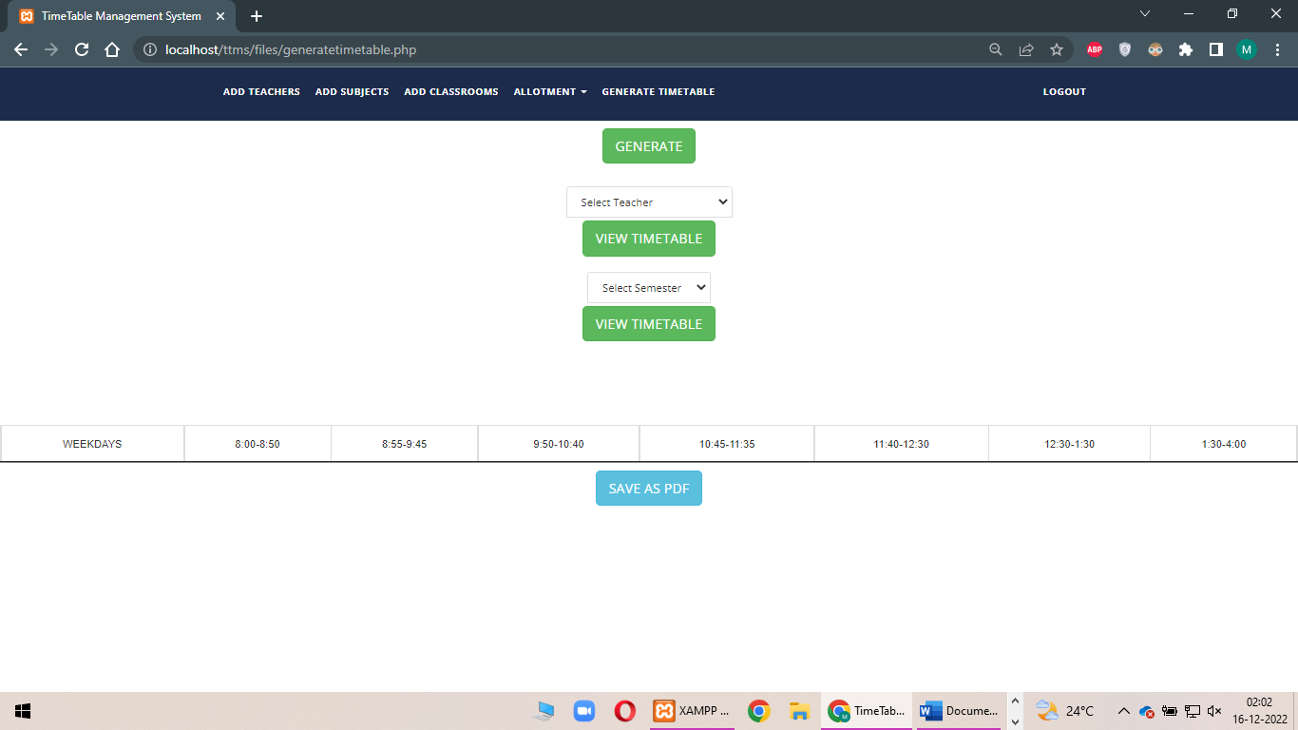

Fig 2O Admin Page- Generate Timetable

To generate the Timetable the following process should be done:

**AFTER CLICKING THE GENERATE BUTTON TIME TABLE GETS GENERATED:**

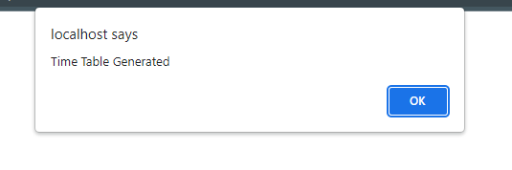

Fig 2P Admin Page – Generate Timetable

Successfully the time had been generated.

**AFTER THE SUCCESSFUL GENERATION OF THE TIMETABLE:**

**WE CAN GET THE TIMETABLE OF INDIVIDUAL STAFF BY CHOOSING THE STAFF:**

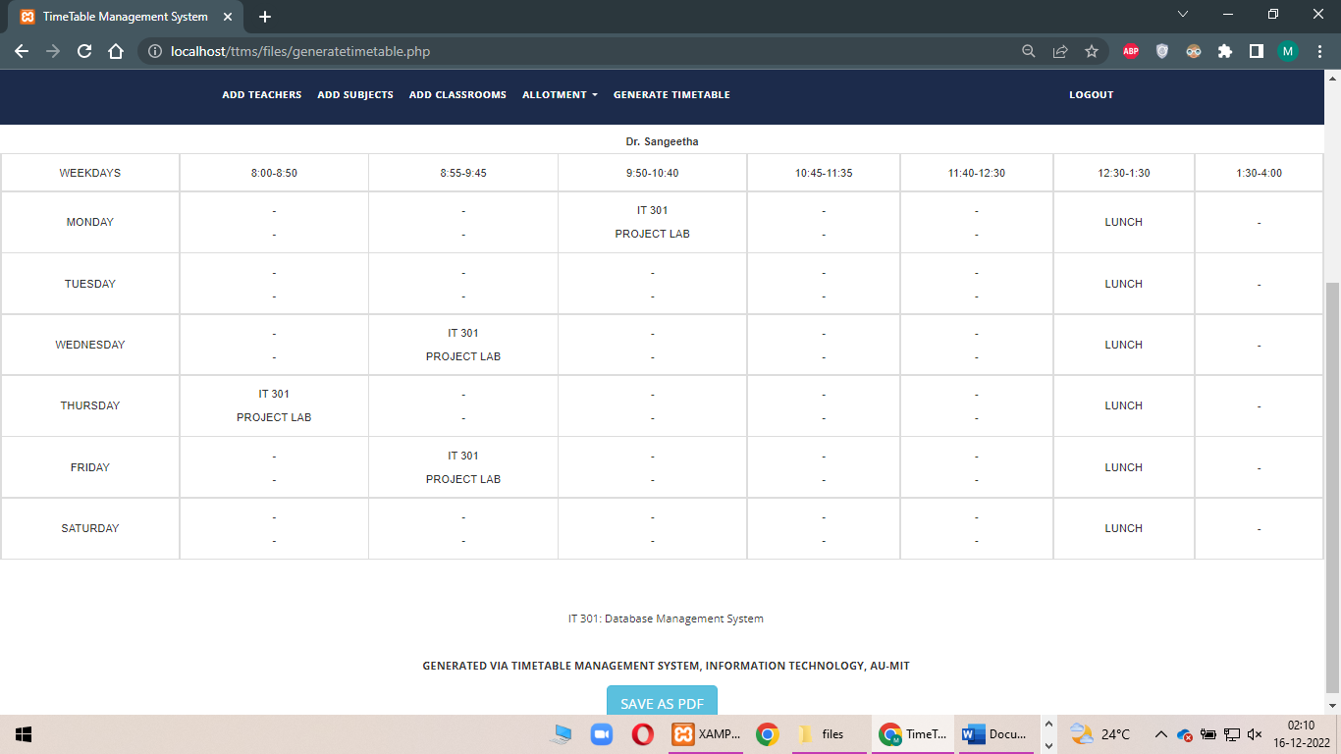

Fig 2Q Admin page – Generate Timetable

**CHOOSING THE TIMETABLE FOR THE PARTICULAR SEMESTER:**

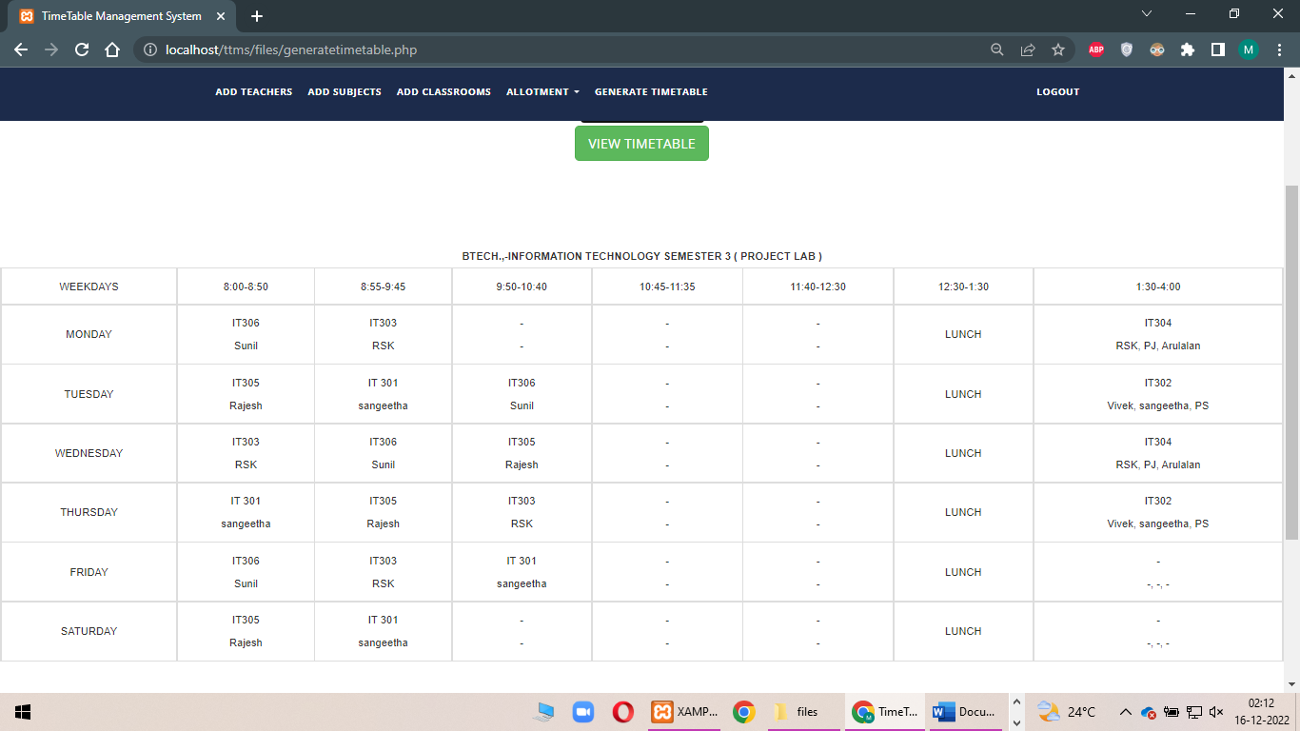

Fig 2R Admin Page – Generate Timetable

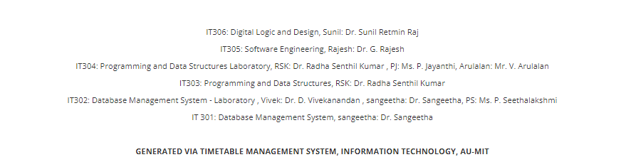

Thus the timetable generation has been successfully completed by the process.

**AFTER LOGGING OUT OF THE ADMIN:**

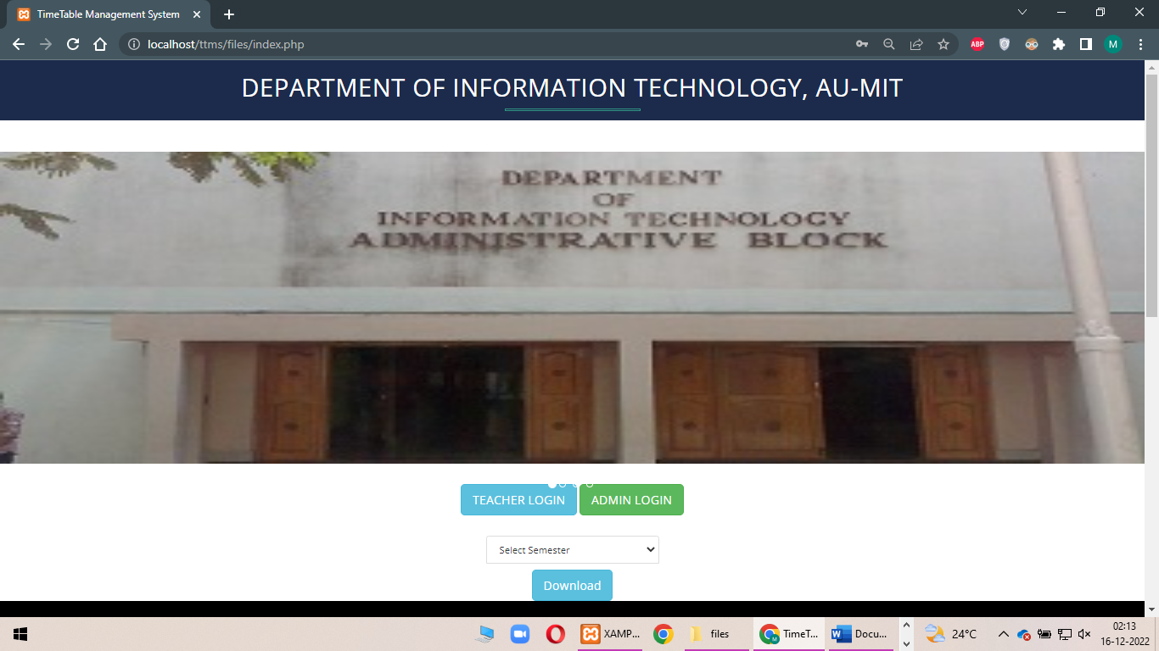

Fig 3A Home Page

**NOW LOGGING TO THE TEACHER LOGIN:**

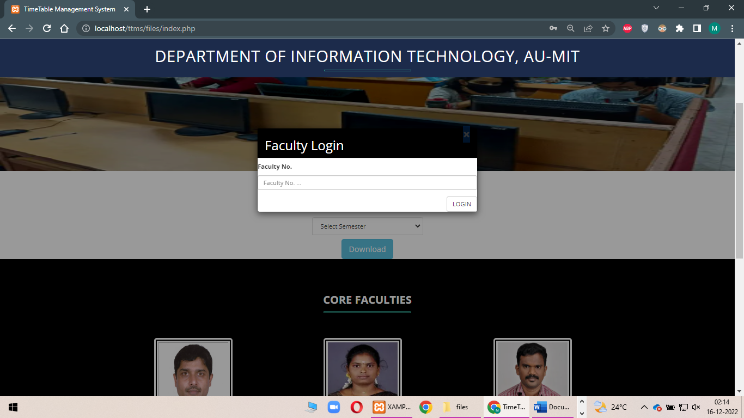

**ENTERING THE FACULTY ID**:

We can get the faculty with her details.

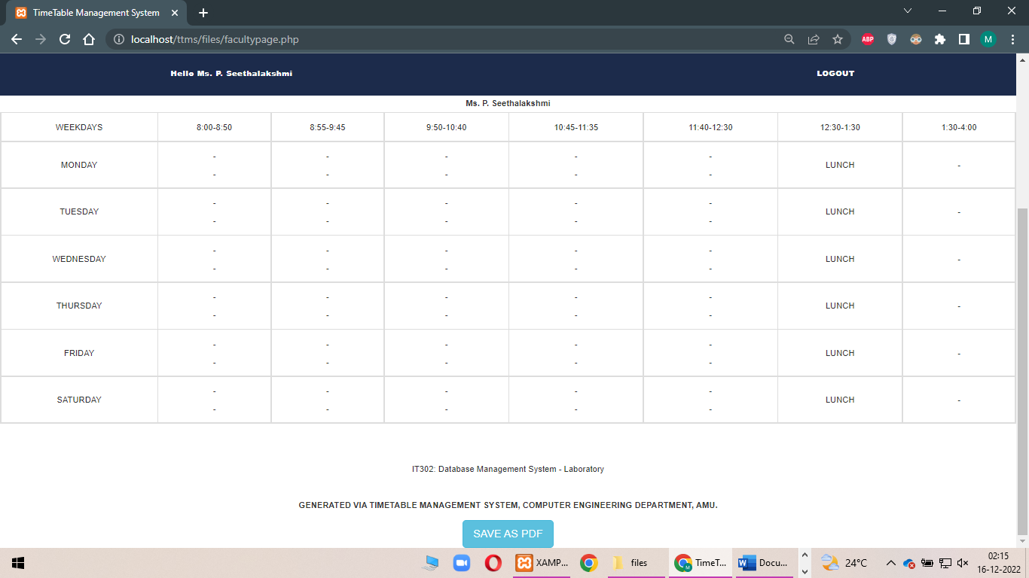

**After logging out of the teacher login:**

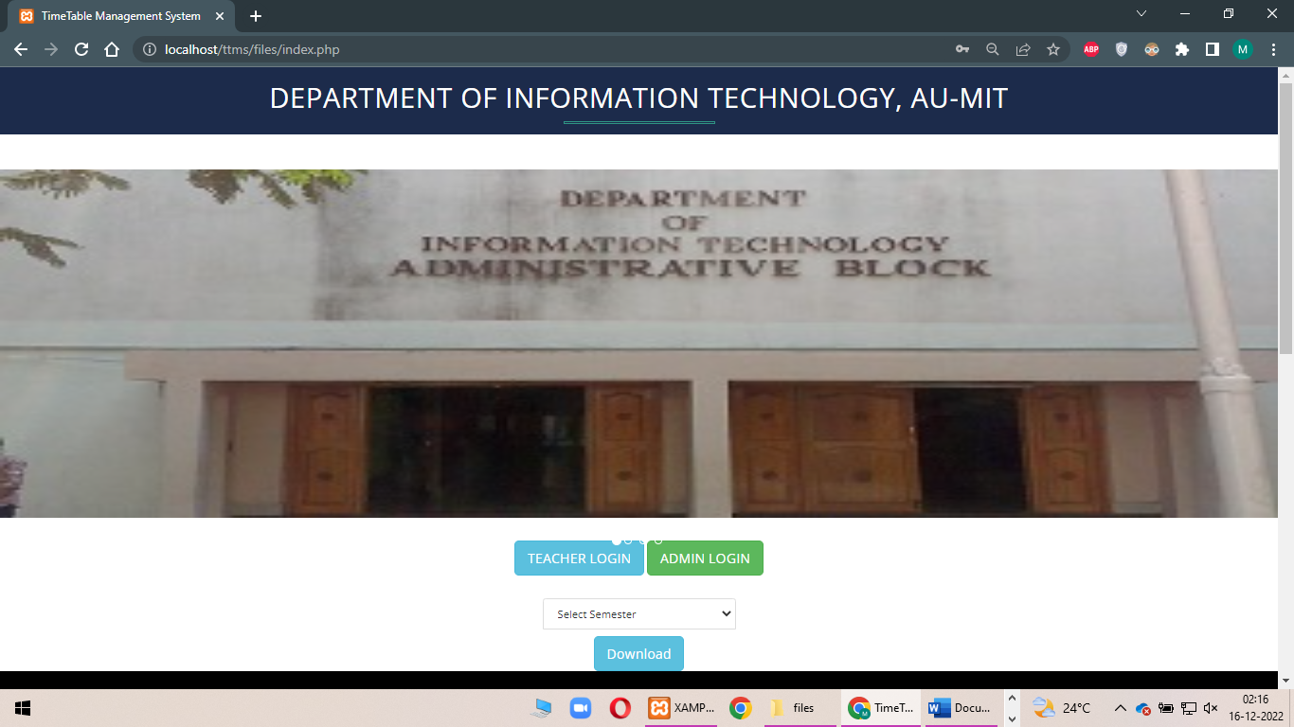

**ALSO WE CAN DOWNLOAD THE TIMETABLE OF THE PARTICULAR SEMESTER WITH THE OPTION GIVEN IN THE HOME PAGE:**

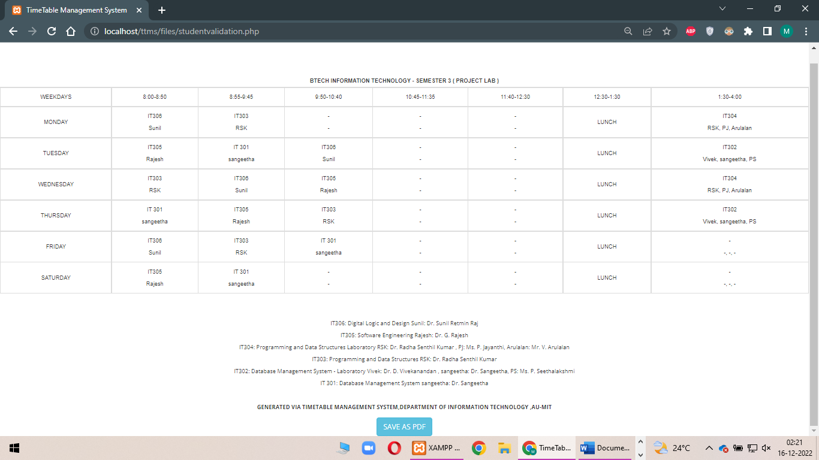

**RESULT:**

Thus the total working of the project has been explained above. Thus the timetable has been successfully generated.